1. Outer Shell

**NOTE: More info will be given between figures also RENDER images left**

As the pod size is comparatively smaller and the run is being done in open air, we aimed for a highly efficient design of the shell. The material used for the panel is going to be glass fibre. This material was chosen instead of carbon fiber because of its cost effectiveness and availability.

1.1 Aerodynamic design

Isometric view

Top view

We decided that rather than considering panels with extreme pressure conditions which could be prone to vibrations during the run, focusing on designing a panel with more stability is better as the run is being conducted in open air.

2. Analysis

2D CFD



2D CAD model of Panel in Enclosure

The velocity of the pod is 100km/hr as a result the inlet velocity has been taken as 27.77m/s. A k-epsilon viscous model has been considered and the initial pressure is taken as 1 atm with a density of 1.225kg/m^3.

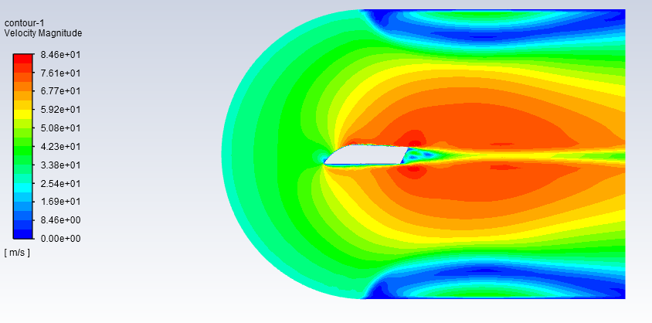

Velocity contour of 2D panel

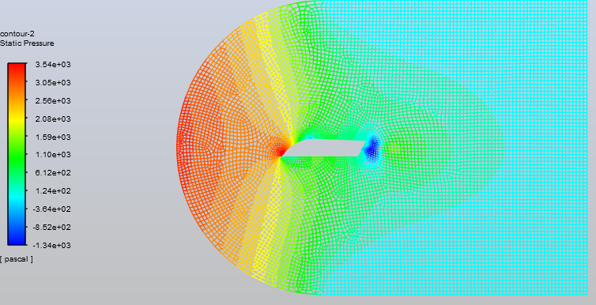

Static Pressure Contour along with mesh of 2D Panel

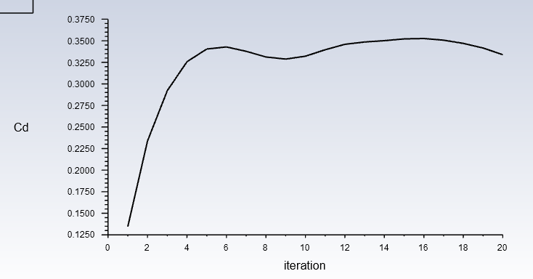

Cd vs Itertation for 2D Panel

Coefficient of Drag for 2D analysis is 0.324

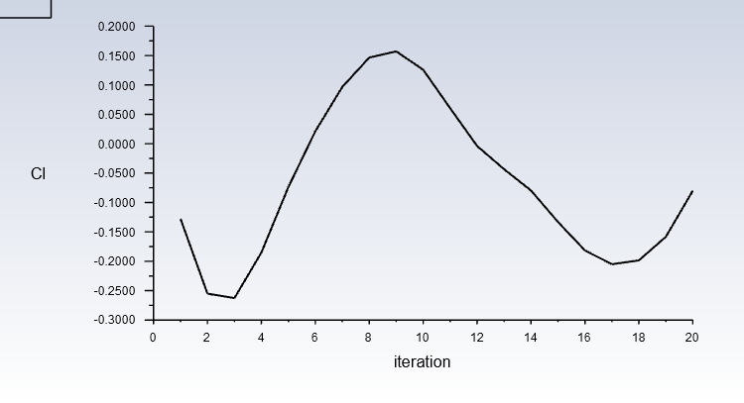

Coefficient of lift for 2D analysis is –0.11. The coefficient of lift obtained is negative thus indicating a negative lift or downforce

3D CFD

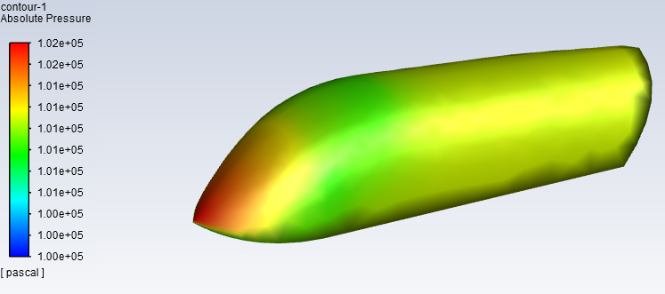

Absolute Pressure contour of 3D Panel

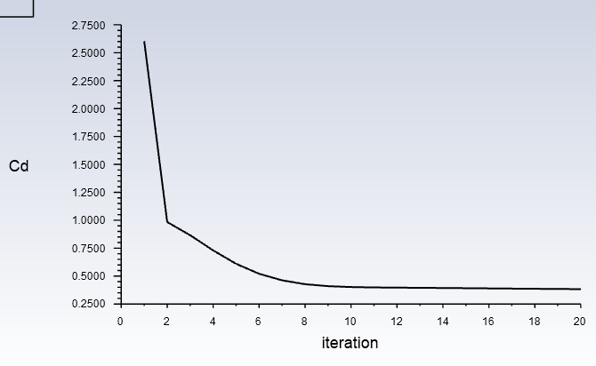

Cd vs Iteration for 3D Panel

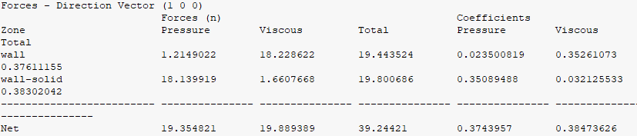

Coefficient of Drag for 3D panel is 0.38

Total Drag force is 19N

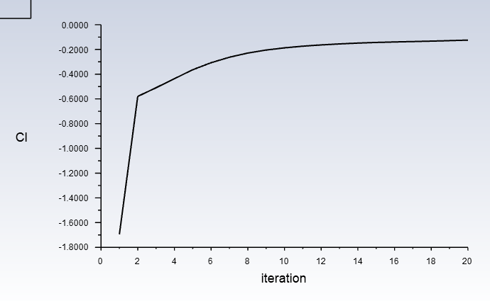

CI vs iteration for 3D panel

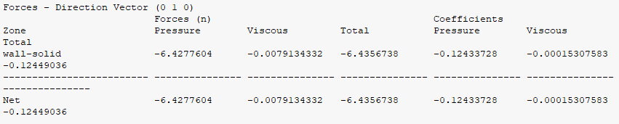

Coefficient of Lift for 3D panel is –0.2

Total Lift Force is –6N